|  |  |  |  |  |  |  |
| --- | --- | --- | --- | --- | --- | --- |
| **Mehran University of Engineering & Technology,**  **Jamshoro** | |  | **Subject** | | | |
| **Web Technology** | | | |
| **Department of:**  **Bachelor of Science Computer Science** | | **Year** | **2nd** | **Semester** | **3rd** |
| **Roll No:** | **20BSCS043** | **Batch** | **20BSCS** | **Duration** | **3 Hours** |

**PRACTICAL # 12**

**TO DESIGN THE DATABASES WITH THE HELP OF PHP**

# LAB TASKS



**Task # 1:** Create a database for registration form, which takes Name, Roll Number, Section via PHP file and store form data in Database using PHP.

**PHP FILE CODE :**

<form style="width:30%; margin:0 auto" action="savedata.php" method="post">

  <div class="mb-3">

    <label for="exampleInputEmail1" class="form-label">Name</label>

    <input type="text" class="form-control" name="name">

  </div>

  <div class="mb-3">

    <label for="exampleInputPassword1" class="form-label">Roll No</label>

    <input type="text" class="form-control" name="roll_no">

  </div>

  <div class="mb-3">

    <label for="exampleInputPassword1" class="form-label">Section</label>

    <input type="text" class="form-control" name="section">

  </div>

  <button type="submit" class="btn btn-primary">Save</button>

</form>

<?php

 $name =   $_POST['name'];

 $roll_no = $_POST['roll_no'];

 $section = $_POST['section'];

//  echo $snumber;

//  echo $sname;

//  echo $sclass;

//  echo $snumber;

$conn = mysqli_connect('localhost','root','','school') or die("Connection Unsucceessfull");

$sql = "INSERT INTO `student`(`name`, `roll_no`,`section`) VALUES ('{$name}','{$roll_no}','{$section}')";

$result = mysqli_query($conn,$sql) or die("Query Failed");

header('Location:read.php');

?>

**Output:**

**Database:**

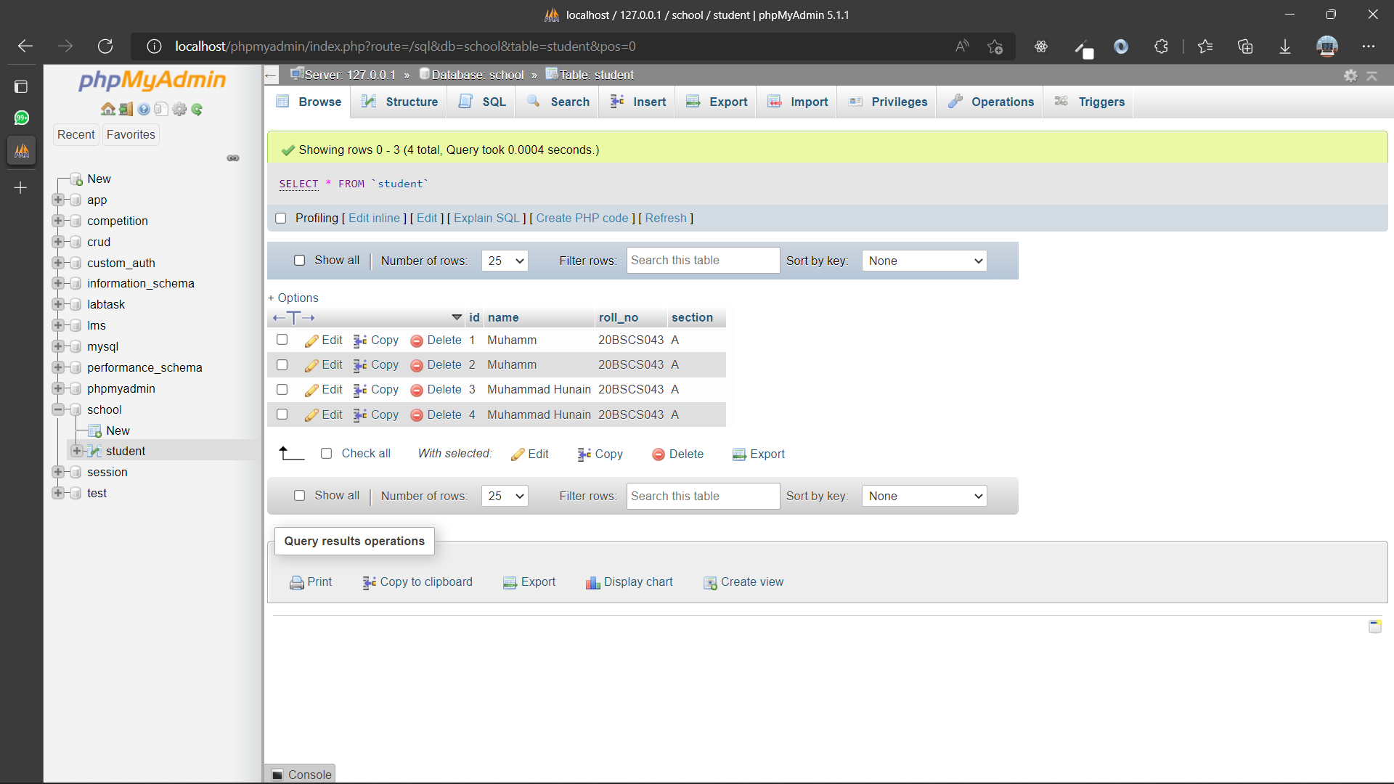

**Task # 2:** Create a webpage which shows name, marks of subjects and grade from already stored database.

**PHP FILE CODE :**

<?php

    $conn = mysqli_connect('localhost','root','','school') or die("Connection failed");

    $sql = "SELECT * FROM student_report";

    $result = mysqli_query($conn,$sql) or die("Query Failed. ");

    if(mysqli_num_rows($result)>0)

    {

?>

<table class="table">

  <thead>

    <tr>

      <th scope="col">Student id</th>

      <th scope="col">Student Name</th>

      <th scope="col">Grade</th>

      <th scope="col">English Marks</th>

      <th scope="col">Math Marks</th>

      <th scope="col">Urdu Marks</th>

      <th scope="col">Pst Marks</th>

    </tr>

  </thead>

  <tbody>

      <?php

        while($row = mysqli_fetch_assoc($result)){

      ?>

    <tr>

      <td><?php echo $row['id'] ?></td>

      <td><?php echo $row['name']?></td>

      <td><?php echo $row['grade']?></td>

      <td><?php echo $row['ENGLISH']?></td>

      <td><?php echo $row['MATH']?></td>

      <td><?php echo $row['URDU']?></td>

      <td><?php echo $row['PST']?></td>

      <td>

          <a href="./update.php?id=<?php echo $row['id']?>" class="btn btn-primary">Edit</a>

          <a href="./delete.php?id=<?php echo $row['id'] ?>" class="btn btn-primary">Delete</a>

        </td>

    </tr>

    <?php } ?>

  </tbody>

</table>

 <?php }

 else{

    echo"<h2>No record Found</h2>";

 }

 mysqli_close($conn);

 ?>

OUTPUT :

DATABASE :

**Task # 3:** Create a webpage which will take Student Roll Number in a search box and display the student data accordingly: Name, Roll Number and Section from database.

**PHP FILE CODE :**

 <form action="./update.php" method="post">

    <h1>Search Rercord</h1>

  <input type="search" name="data" placeholder="Search Roll Number" class="form-control w-25">

  <input type="submit" class="btn btn-primary my-3 ">

    </form>

<?php

$conn = mysqli_connect('localhost','root','','school') or die("Connection failed");

$id = $_POST['data'];

$sql = "SELECT * FROM `student` WHERE roll_no = '$id'";

$result = mysqli_query($conn,$sql) or die("Query Failed.");

if(mysqli_num_Rows($result)>0){

  while($row = mysqli_fetch_assoc($result)){

?>

<form style="width:30%; margin:0 auto" action="/" method="post">

  <div class="mb-3">

    <input type="hidden" class="form-control" name="id" value="<?php echo $row['id']?>">

    <label for="exampleInputEmail1" class="form-label mt-5"><h5>Name</h5></label>

    <input type="text" class="form-control " name="name" value="<?php echo $row['name']?>">

    <label for="exampleInputEmail1" class="form-label"><h5>Roll No</h5></label>

    <input type="text" class="form-control " name="name" value="<?php echo $row['roll_no']?>">

    <label for="exampleInputEmail1" class="form-label"><h5>Section</h5></label>

    <input type="text" class="form-control " name="name" value="<?php echo $row['section']?>">

  </div>

</form>

<?php

  }

}

else{

  echo "<h1 style='color:red; text-align:center'class='my-5'0 >Not Found</h1>";

}

?>

**OUTPUT:**

**DATABASE**

|  |  |  |
| --- | --- | --- |
| Rubrics | Marks Obtained | |
| 0 | 1 |
| Completeness & Accuracy |  |  |
| Timelines |  |  |

|  |  |
| --- | --- |
| Student ID: |  |
| Subject Teacher: |  |
| Date: |  |